FRAUDS! are…

David Allen ([dpallen@wpi.edu](mailto:dpallen@wpi.edu))

Henry Wheeler-Mackta ([hjwheelermackta@wpi.edu](mailto:hjwheelermackta@wpi.edu))

# Working Game Title:

“Power Pop”

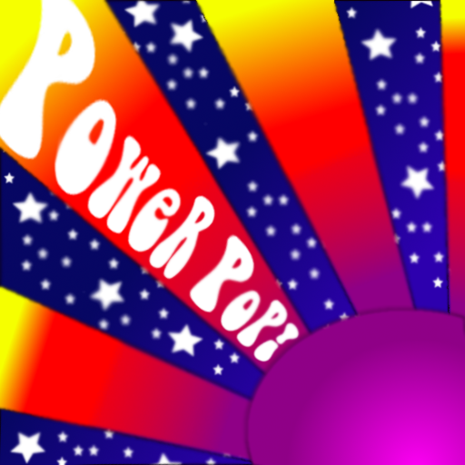

Figure 1: Working Game Logo

# Logline:

“The groovy musical bubble-wrap that pops itself!”

# Summary:

Power Pop is a musical-themed puzzle game that incorporates rhythmic song generation into the creation of click-based chain reactions. The game features numerous individual orbs that can be clicked on to detonate, with each detonation resulting in several smaller missiles shooting out of the detonation point. If a missile hits another orb, that orb detonates. If it hits the game’s border, it places a note at that spot. The goal of the game is to detonate each orb using the allotted amount of clicks, utilizing their chaining potential to ensure that each is detonated, whilst simultaneously creating a pseudo-randomly-generated song.

* Click on an orb to destroy it.
* Each destroyed orb releases missiles that can destroy other orbs.
* Bigger orbs may take more clicks/missiles to destroy.
* An ongoing metronome ensures that the music never stops.
* Add a note to the ongoing composition by causing a missile to hit the game border.
* Popping an orb clears the level and repopulates the grid.
* Some orbs are locked, and must be popped through chain reactions.

# Target Audience:

Power Pop is intended for casual players who enjoy popping things – both the act and resulting audio/visual outcome.

# Experience Goals:

The goal of Power Pop is to provide an engaging puzzle experience to the player that feels both rewarding and exciting to solve. This is accomplished through the ongoing reward system of gradual song creation. Additionally, the quicker the player pops the orbs, the quicker the song is created, encouraging clever usage of chain-reactions and prioritizing certain orbs’ destruction over others.

Through the overhauled audio/visual elements, Power Pop also aims to recreate that dreamy, nostalgic, and zoned-out feel that is commonly attributed to the counter-culture musical movements of the mid-to-late twentieth century.

# Gameplay Description:

## Grids within Grids

The Power Pop grid is composed of two major grids – the inner grid and the outer grid. The inner grid is where the orbs are located, thus being where most of the in-game action takes place. The outer grid is where the notes are formed – thus being where a good portion of the game’s feedback and audio queues are given. Direct and indirect usage of both grids is crucial to solving the puzzles provided by Power Pop.

## The Orbs

Popping the orbs are the primary action in Power Pop, yet not all orbs can be popped in a single click. A given orb can be at one of three stages, with each stage being closer to the popping state. Each stage is communicated via the orb being at a certain size – going from small to large. The largest size requires one more click to pop, while the smallest size requires three more clicks to pop.

Popping an orb results in four missiles being shot in each cardinal direction from the orb’s center. These missiles serve to either pop subsequence orbs or add a note to the outer grid.

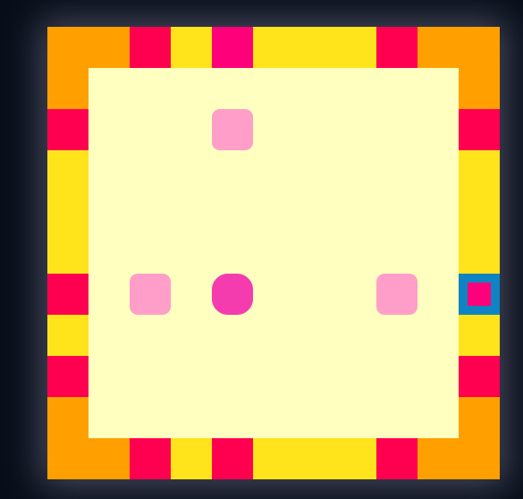 Some orbs are locked and cannot be popped via clicking – they must be popped through the missiles released by other orbs.

Figure 2 : The grid

## The Missiles

The missiles are the crux of Power Pop’s popping mechanic. Four missiles are released from each popped orb going in each cardinal direction (directly up, directly left, directly right, and directly down). If a missile hits another orb, that orb’s size is increased by one – or it pops if it is already at maximum size. If a missile hits the outer grid, a note is placed at that spot. Missiles go through other missiles.

The missiles themselves are represented as ghostly beads that reflect the color of the popped orbs. Their aesthetic contributes to the game’s dreamy atmosphere via being the only moving elements, thus existing in contrast to the notes, beads, and overall grid’s stationary nature.

## The Inner Grid

The inner grid contains orbs and missiles, and itself contains a grid of 8 by 8 orbs – thus allowing for a potential total of 64 orbs. There is space between each orb to allow for proper animation of missile travel to take place. The inner grid is surrounded by the outer grid.

## The Outer Grid and Notes

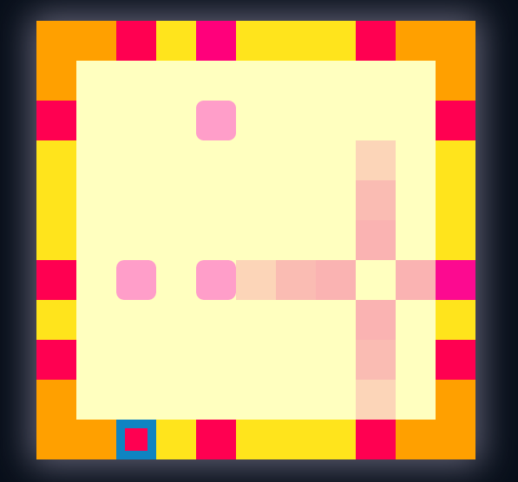 The outer grid surrounds the inner grid, and is initially blank and empty. When missiles hit the outer grid, it creates a note at that spot. Further missiles hitting the same spot on the outer grid will heighten the intensity of the note. Notes are all on the pentatonic scale to ensure that the resulting song is musically pleasing.

Figure 3 : Missiles in motion

Additionally, each potential note has six inherent variations that can potentially be played. This prevents the playback from sounding artificial and stilted.

## Musical Playback

The outer grid contains a sound player that rotates around the inner grid. When it crosses a placed note, it plays that note. This sound player repeats as long as the application is open. The outputted sound is taken from a dreamy, atmospheric synth as opposed to the default Perlenspiel sounds.

## Mouse-Based Interaction

To ensure that Power Pop is intuitive to use, all interaction is accomplished via the mouse, with the interaction itself being minimal – the only possible action is to click on an orb. Clicking on a given orb will cause it to pop, with the resulting missiles and further popping being accomplished without user input.

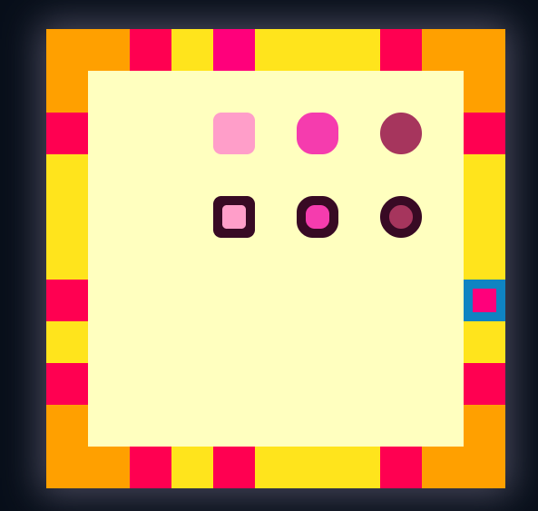

Figure 4 : Unlocked versus locked orbs

## Limitations, Scoring, and Levels

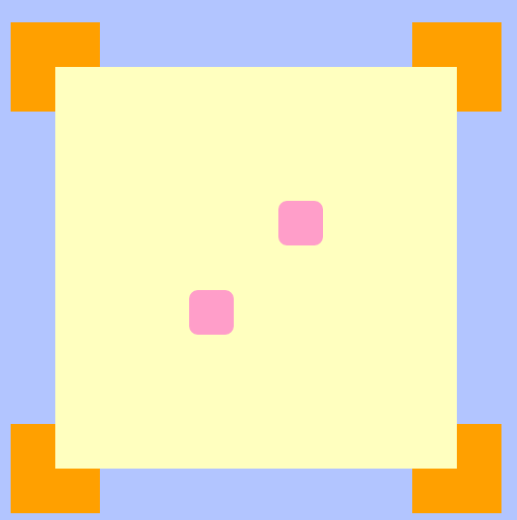The difficulty of Power Pop comes in how it limits maximum player clicking – a given level may allow only a few clicks before resetting. Popping every orb must then be accomplished via chain reactions – relying on the resulting missiles to pop further orbs. Earlier levels will feature less orbs to pop, with later levels featuring more at varying sizes. Scoring will be represented at the top of the screen via the status line – with the players’ score going up based on popping orbs and song completion. Each popped orb will increase the score, but clearing a board and thus creating a finished song will substantially increase the score.

If the player fails to complete a board due to running out of clicks, the level will reset – their score and overall progress will not be revoked.

## The Reveal

To prevent the player form being immediately overwhelmed by several mechanics, only the primary play space is initially revealed – this including the inner grid and orbs within. After a few levels, the outer grid and musical playback is initialized.

Figure 5 : Playspace pre-reveal

# Playtest Survey:

Did you immediately understand the puzzle’s win condition?

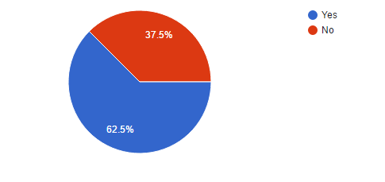

After how many levels do you realize how popped beads interacted with each other?

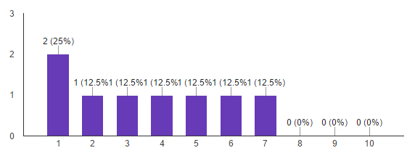

After how many levels did you realize how popped beads interacted with the music?

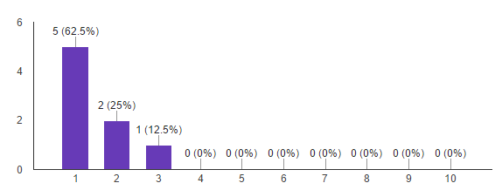

How enjoyable was the generated music?

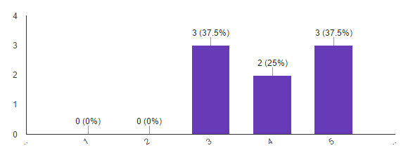

How difficult were the puzzles?

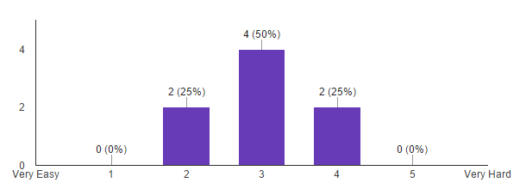

Were any puzzles excessively difficult?

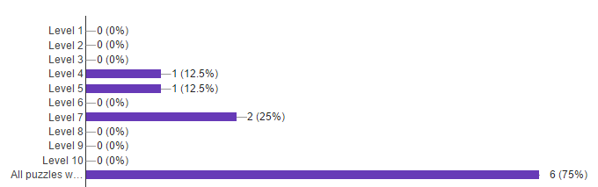

How visually appealing was the primary playspace?

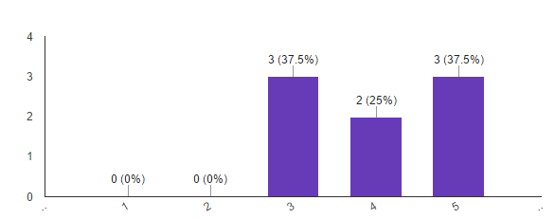

How visually appealing was the note border?

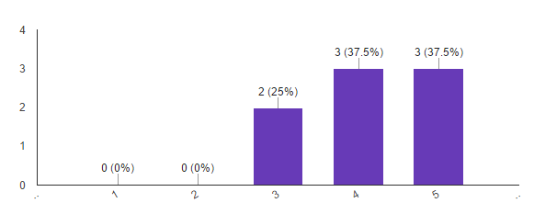

# Playtesting Notes:

* Level 10 has a repeating bug where it will not progress after completion
  + This was fixed by overhauling how victory/failure checking was accomplished
* Players had difficulty with newly-introduced mechanics
  + This was fixed by adding more introductory levels
* Players were initially confused by the drum grid and note grid
  + The drum grid was removed entirely, and the note grid is now revealed after the introductory tutorial levels
* Players had difficulty distinguishing between the different orb sizes
  + This was fixed by overhauling the difference in orb size and color
* Level 7 was considered too difficult by most players
  + Level 7 was substantially reduced in difficulty
* Players beat the game in too short a time frame
  + The total levels were doubled

# Critique:

* The interaction between missiles and notes was initially confusing
  + The reveal level was slightly modified to shift the focus from a complicated orb-to-orb reaction to a more simplified missile-to-note reaction
  + Notes now pulse when modified
* The default Perlenspiel xylophone sounded artificial, stilted, and uninspired
  + A custom synth was built and implemented
  + Multiple versions of each individual note were implemented, all with different velocities, durations, and tonalities

# Product Details:

## Member Roles

David Allen – lead programmer, sound designer, mockups

Henry Wheeler-Mackta – programmer, writer, artist, producer